Get code blocks from <https://www.codeblocks.org/downloads/binaries/#imagesoswindows48pnglogo-microsoft-windows>

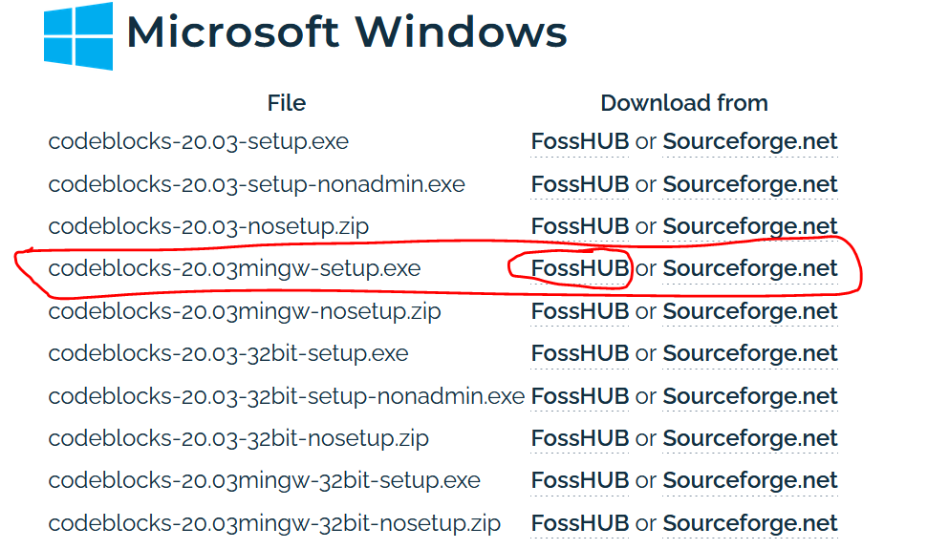

Right click the project and go to build options

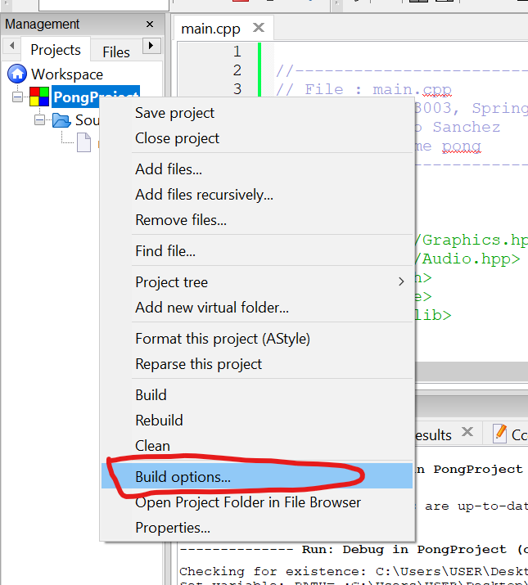

Go to Search Directories and under compiler add the include directory which in the SFML-2-5-1 folder

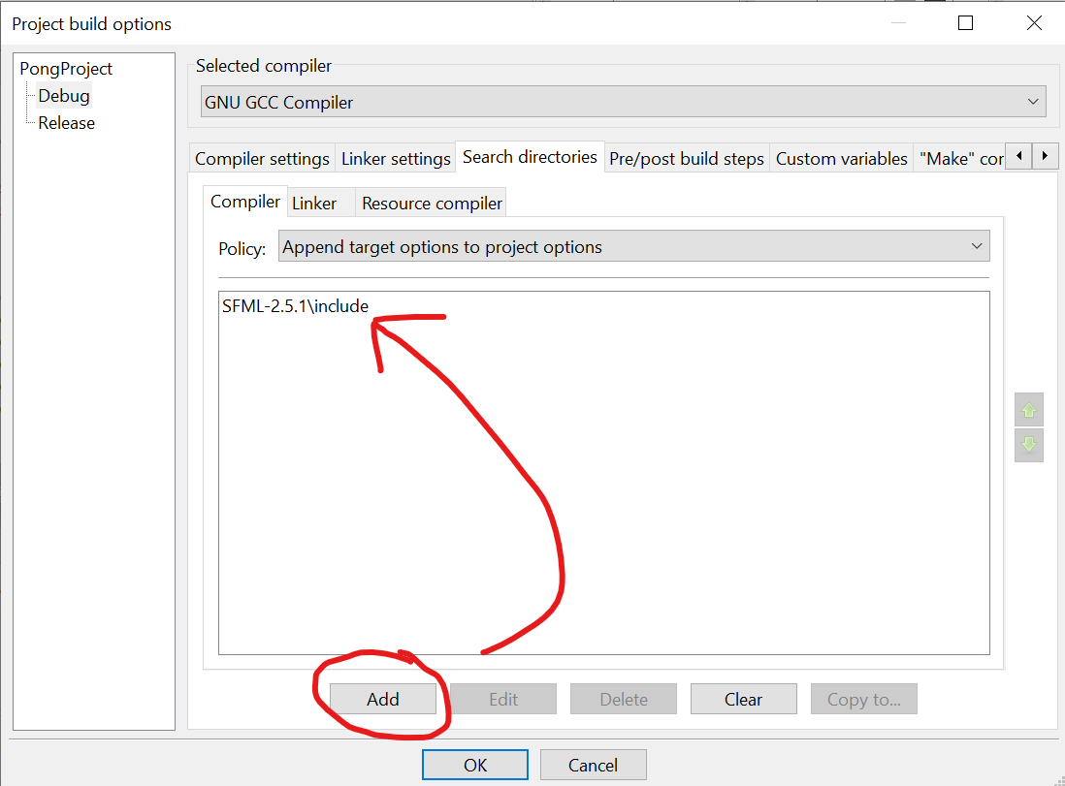

Add lib folder for the Linker

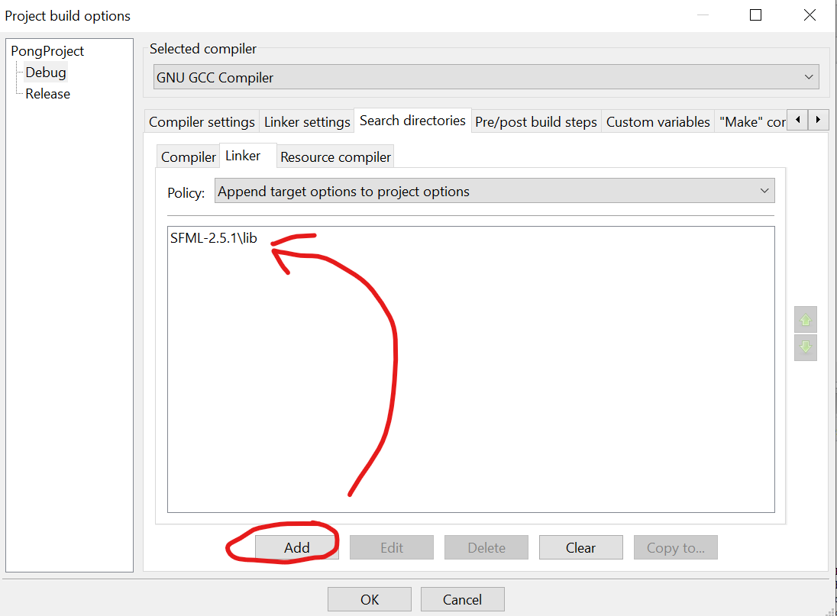

Add the five files listed below under the Linker settings

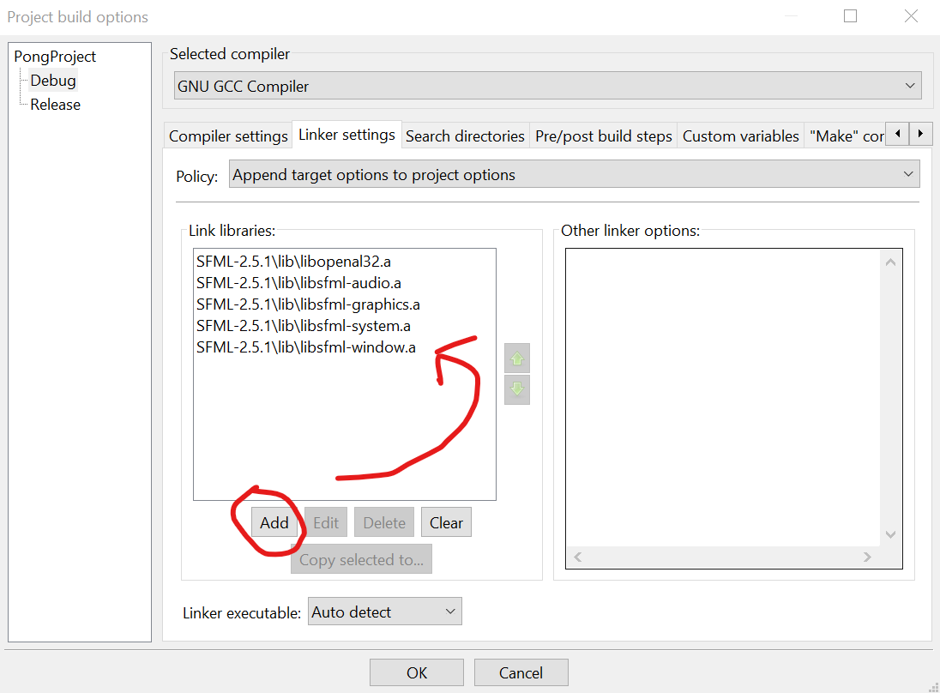

Add SFML_STATIC under Compiler settings > #defines

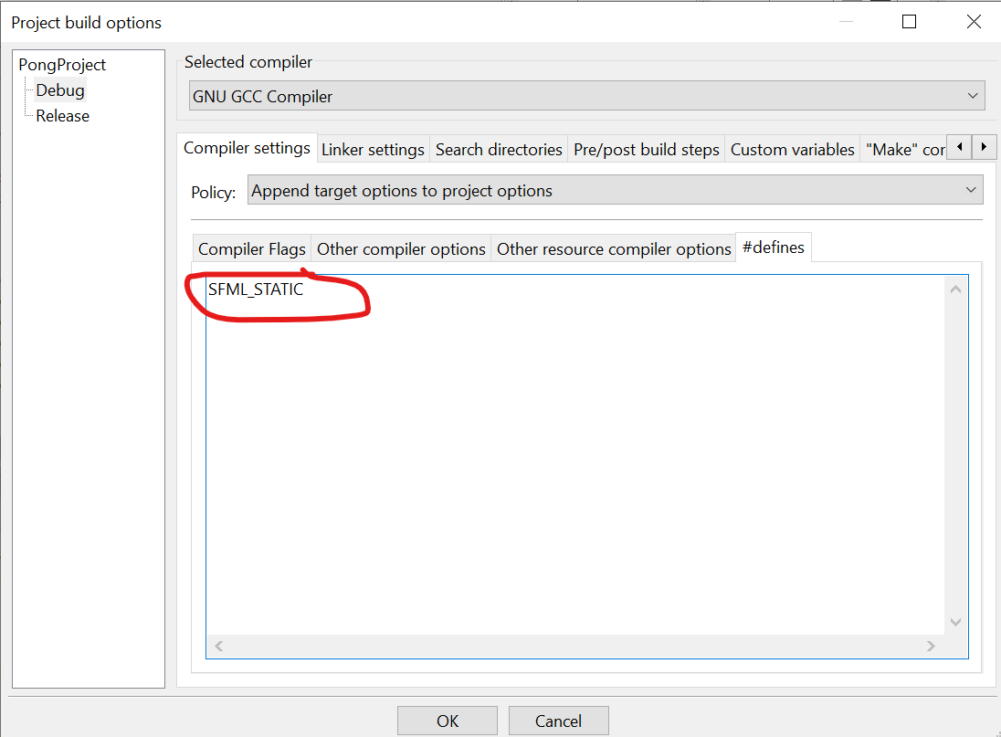

Copy files required from bin folder to root of the project

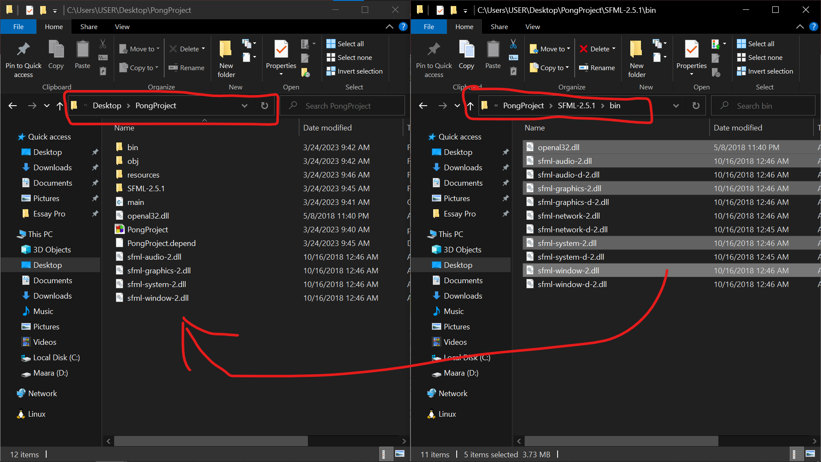

.

Now the project should build and run

